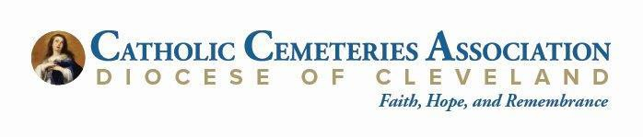

**POSITION TITLE:** Human Resources Administrator

**DEPARTMENT:** Corporate

**SUPERVISOR’S TITLE:** Chief Operations Officer

**POSITION STATUS:** Exempt

# Position Summary:

The Human Resources Administrator is responsible for managing the day-to-day operations of the human resources department. The role involves a wide range of HR activities including recruitment, onboarding, employee relations, performance management, training, HR compliance, safety compliance documentation, and administration of HR policies and procedures.

**Key Responsibilities:**

1. **Recruitment and Onboarding:**
   * Assist in the recruitment process including posting job advertisements, screening resumes, and scheduling interviews.
   * Coordinate and conduct new hire orientation sessions.
   * Prepare and maintain employee personnel files.
2. **Employee Relations:**
   * Serve as a point of contact for employee inquiries regarding HR policies, procedures, and programs.
   * Assist in resolving employee relations issues and provide guidance to managers and employees.
3. **Performance Management:**
   * Support the performance appraisal process, including tracking completion and following up with managers and employees.
   * Assist in the development and implementation of performance improvement plans.
4. **Training and Development:**
   * Coordinate training sessions and seminars.
   * Maintain training records and assist in the development of training materials.
5. **Compliance:**
   * Ensure compliance with federal, state, and local employment laws and regulations.
   * Assist in the preparation and submission of required reports and documentation.
6. **HR Administration:**
   * Maintain Paycor HR systems and databases, ensuring data accuracy and confidentiality.
   * Prepare HR-related reports and presentations as needed.
   * Assist with limited benefits administration including enrollments, changes, and terminations.
7. **Other Duties:**
   * Participate in HR projects and initiatives to improve HR processes and employee engagement.
   * Perform other related duties as assigned.

**Qualifications:**

* Bachelor’s degree in Human Resources, Business Administration, or a related field.
* 2-4 years of experience in a similar HR role.
* Strong knowledge of HR principles, practices, and employment laws.
* Proficient in HRIS systems and MS Office applications.
* Excellent communication and interpersonal skills.
* Strong organizational and time management skills.
* Ability to handle confidential information with discretion.

**Preferred Qualifications:**

* SHRM-CP or PHR certification.
* Experience with recruitment and employee relations.
* Knowledge of benefits administration.
* Paycor familiarity is a benefit.

**Working Conditions:**

* Office environment.
* Occasional travel may be required.

**Salary Range:** $54,193.00 - $73,161.00

# This position will be open to CCA applicants from July 15, 2024 until filled.

**TO APPLY:** Send cover letter, resume and a list of at least three professional references, to: [jobs@clecem.org.](mailto:jobs@clecem.org) You must place **HR Administrator** in the email subject. No phone calls or walk-in applications, please. E.O.E.